 TRIBHUVAN UNIVERSITY

INSTITUTE OF ENGINEERING

PULCHOWK CAMPUS

# 

# **REPORT ON BRICK BREAKER**

Date: 22nd Asar, 2079

**SUBMITTED BY: SUBMITTED TO:**

Prajjwal Pandey(077BCT055) Department of Electronics and Computer

Prasun Sitaula(077BCT057)

# **ACKNOWLEDGEMENT**

Knowledge is not just limited on our books and our words; it differs on our experience, on a way we face the time and situation that passes across us. The project work on C++ is an excellent way to collaborate the knowledge in our mental altitudes in computer sector.

We would like to express my sincere gratitude to all the personalities who played a supportive role in bringing this project to the height of success. First of all, we would like to thank **our parents** who helped us a lot by providing suitable environment, accessories, economic support, etc. required for the project. Secondly, we would like to express our thanks of gratitude to subject teacher and computer instructor **Mr.Daya Sagar Baral** who provided us a golden opportunity for creating a project in C++ and are also thankful for his help and guidance. Besides, we would like to thank **college management** too. Finally, we extend our gratitude to our fellow programmers worldwide who helped a lot in getting new ideas and other helpful hands that helped us a lot in finalizing this project within the limited time frame.

I am also grateful for the insightful comments offered by our friends. The generosity and expertise of one and all have improved this project in innumerable ways and saved us from many errors.

Computer is an integral part of our life. Only theoretical development in Computer doesn’t necessarily bring positive impact in computer sector. Practical portion are indispensible also for the development in the computer sector. By doing this project, we really developed our skills related to different uses and applications of Object Oriented Programming.

Really, this project is **“an excellent example of a coordinated and united team and other** **helpful faces and hands.”**

# TABLE OF CONTENTS

1. INTRODUCTION………………………………………………4
2. OBJECTIVES…………………………………………………...5
3. PROPOSED SYSTEM………………………………………….6

I.SYSTEM BLOCK DIAGRAM

II.BLOCK DIAGRAM

1. METHODOLOGY………………………………………………7
2. PROJECT SCOPE……………………………………………….8
3. PROJECT SCHEDULE………………………………………….9

# INTRODUCTION

Brick Breaker project is a minor project proposal for our academic session B.E. (computer) Second Year First Part as prescribed in the syllabus. The main aim of this project is to develop a user-friendly program using an object oriented programming language, C++.

Brick Breaker, is a 2D shooter game where user tries to smash a wall of bricks by deflecting a bouncing ball into it while aim is assisted by paddle. The game is simple shooter genre but has a cult of professional players trying to achieve high scores. The game is based on C++ using SDL(Simple DIrectMedia Layer) as a development library. At present, there are many similar games at various online platforms with different names and is very popular for being simple and competitive at the same time. Bricks Breaker may be an old game but it is still endured by many people, both children as well as adults. During the game development it brings back our old memories and while playing this game will take us back to our wonderful childhood.

This program might not compete with the program made by the mainstream developers but serves as a introducing medium for us wit challenging shooter game in LAN, as we approach learning complex programming. Also, it is fun to play.

# OBJECTIVES

* To create an Object Oriented Programming(C++) based program.
* To explore features of C++ Language and SDL development Library.
* To be familiar with resource re-usability by making user defined header files.
* To learn basics of game development and game physics.
* To introduce ourselves with graphics programming in game development using SDL.
* To build an attractive UI so as to ease users while playing game.
* To understand the scope of OOP in major project development.
* To develop research, team work and communicative skills.

### **PROPOSED SYSTEM**

### **DESCRIPTION**

Bricks breaker originally known as Arknoid, is a fun game in which the player breaks the bricks with a ball which can bounce from a paddle located at the bottom which can move horizontally. This game will remind you of the classic arcade games of your past. The player objective is to break all the colored bricks on each level. I order to break a brick, you must hit it with the ball. Some bricks may take more than one hit to break. Use the paddle to avoid the ball from falling to the bottom of the screen. The angle at which the ball bounces off the paddle depends on the point at which the ball hit the paddle. Move the paddle side to side using the mouse and use space to fire the laser when you have the power. But, if the ball hits the bottom enclosure, the player loses and the game ends.

This game features different levels with different difficulties. The player will have 3 lives. A live will be lost if the ball misses the paddle at the bottom. If all lives are lost than, the player loses the game. The player gets points by breaking the brick. Once the player breaks all the bricks, the player will be advanced to a harder level. This game will also feature some unbreakable bricks which will act as barrier for the ball. This game will also have tutorial to teach a new player for playing.

### **BLOCK DIAGRAM**

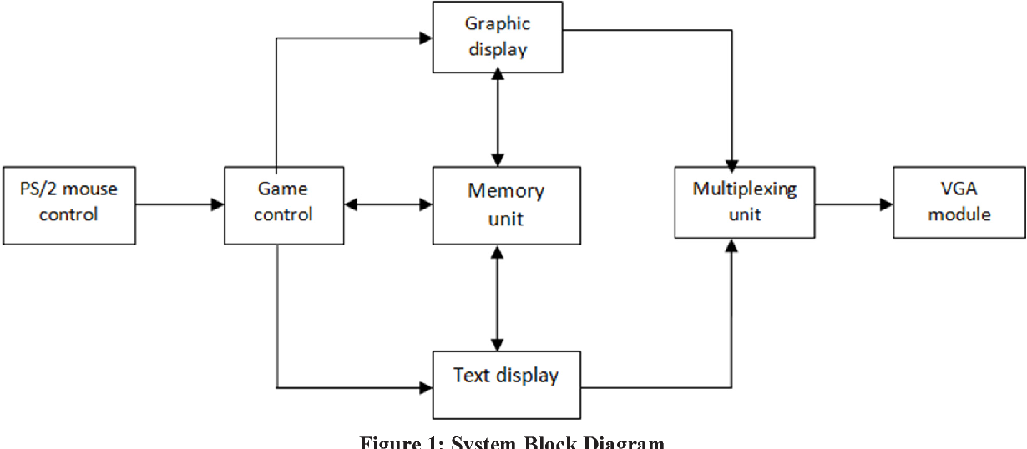

# METHODOLOGY

The project is based on C++ programming language utilizing SDL graphics library and “Object Oriented Programming” concept. The program uses the concept of code classes, functions, re-usability, data abstraction . Similarly, C++ has the ability to manage the memory allocation/deallocation on any objects that we’ve created which can increase the performance of our game.

Game is performance critical software that requires 100% usage of the hardware user has, and c++ is only popular language that gives you such abilities:

* High abstraction level : fine object oriented and generic programming
* Very good and determinism control of the resources you use.
* Ability to optimize special parts to very high level that is almost impossible to achieve with other popular languages.

The strength if C++ when it comes to game development is the ability to exactly layout the data-structures that your software will use. C++ provides the ability to override important performance bottlenecks such as memory allocation. It has the ability to structure and place things exactly where wanted in the memory. On top of this it’s a flexible programming language that provides a decent development velocity.

Since, Visual Studio Code is one of the most popular IDE and both of us are familiar are familiar with it so we decided to use VSC(version 1.68.1) which uses GCC compiler(version 12.1.0) and GDB(version 12.1.0) as debugger. Similarly, SDL is to be used for graphics and other game related works as program calls for complex programming and SDL provides best high resolution 2D graphics development.

Hence, Programming methods to be used can be summarized as:

* Proposal Submission
* Analyzing and Learning the concept
* Discussing the challenges
* Scheduling the project
* Coding the program
* Execution and testing
* Debugging
* Program Documentation

**PROJECT SCOPE**

The main objective of this project is to create a fun game by using object oriented programming concepts and also learn about SDL and apply it in project. Besides entertainment, this program may not have wide range of application in the real world, but it teaches us about software development as a whole. Mini project like this are key for understanding the basic concepts and it also enables us to implement the theoretical knowledge into practical applications.

The project will include research, writing code, testing and debugging as well as taking feedback from friends. The workload is equally divided to each other in our team. The project will be completed within Shrawn 20th and will be submitted before deadline. A short presentation will be also provided after the completion of the project.

In any project, we face a lot of difficulties and constraints. One of the major difficulties that will appear along the development of the project will be time management. Hence, it will be crucial for us manage time.

**PROJECT SCHEDULE**

1. Study Research And Analysis…………………………2 Days
2. Designing the layout of the project……………………2 Days
3. Algorithm Preparation……………………………..…..2 Days
4. Coding ………………………………………………...5 Days
5. Testing…………………………………………………1 Day
6. Debugging……………………………………………..1 Day
7. Modification…………………………………………...1 Day
8. Documentation………………………………………...3 Days

This is proposed schedule and we hope to finish our project in approx. 17 Days.The proposed schedule is made considering college classes and preparation time for assessment which we might encounter later this month of various subjects of third semester.